- FarmerMeetingUnderS²H

*Village-Hankarpur
*District-Buxar
*RMO-Patna

Focus Crop-Paddy Point Discussion -
- Discussion on Cropping pattern in village.
- ExplainthebenefitsofS2HvillageSelectedfarmers.
- Provide information regarding Soil Sample and importance of Soil sample Report.
- Use of balance fertilizer into crops , FYM uses into soil.
- Benefits of root dipping and foliar spray of Uttam Pranam in paddy.
- Benefits of applying Uttam superrhiza in the field before sowing and Mix with FYM.
- Discussion on Paddy Nursery management ,Redwor and Stem borer.
Focussed products-
SN-Uttam Superrhiza, salfi no Gold, Salton, Etc. CPC - Onvix, Uttam AGROS, Pevota, azole etc.

RetailerParticipation-1. Resma krishi udami seva Kendra Hankarpur
Name-Ramakant Singh Mobile - 6204984207
Organised by: Vivek Kumar (UKS- Buxar)
Meeting Attended by-Ashish Pratap Sir(AMM Sasaram)
Dileep Yaduvansi Sir (AM Patna )

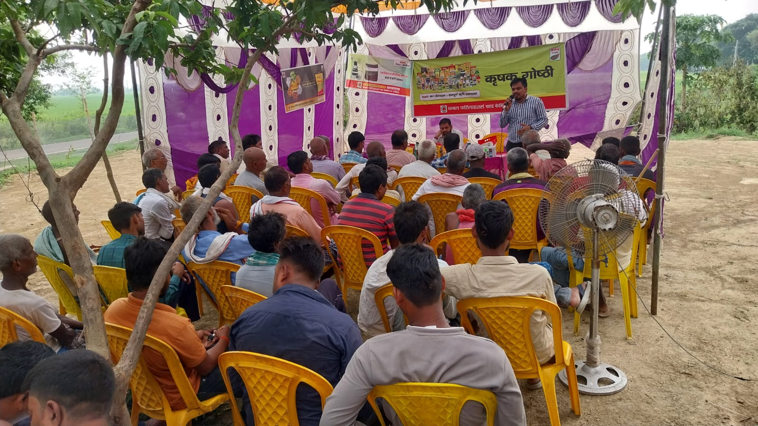
- FarmerMeetingUnderS2H

*Village-Kanehari
*District-Buxar
*RMO-Patna

Focus Crop-Paddy Point Discussion -
- Discussion on Cropping pattern in village.
- ExplainthebenefitsofS2HvillageSelectedfarmers.
- Provide information regarding Soil Sample and
importance of Soil sample Report.
- Use of balance fertilizer into crops , FYM uses into soil.
- Benefits of root dipping and foliar spray of Uttam
Pranam in paddy.
- Benefits of applying Uttam superrhiza in the field
before sowing and Mix with FYM.
- Discussion on Paddy Nursery management ,Redwor
and Stem borer.
Focussed products-
SN-Uttam Superrhiza, salfi no Gold, Salton, Etc. CPC - Onvix, Uttam AGROS, Pevota, azole etc.

RetailerParticipation-1.Rohit khad Bhandar
Name- Rohit Singh
Mobno-+919304742065

Organisedby: Vivek Kumar (UKS- Buxar)
Meeting Attended by- Ashish Pratap Sir (AMM Sasaram)
Dileep Yaduvansi Sir (AM Patna )

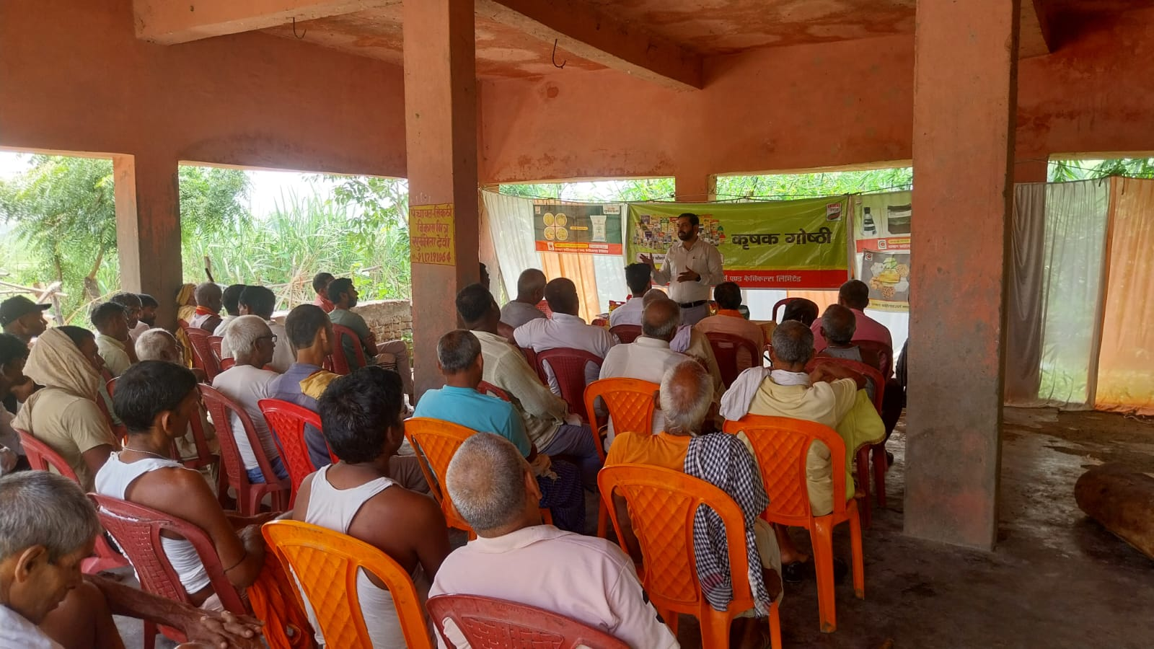

3. FarmerMeetingUnderS²H

*Village- Unwas
*District-Buxar
*RMO-Patna

Focus Crop-Paddy Point Discussion -
- Discussion on Cropping pattern in village.
- ExplainthebenefitsofS2HvillageSelectedfarmers.
- Provide information regarding Soil Sample and
importance of Soil sample Report.
- Use of balance fertilizer into crops , FYM uses into soil.
- Benefits of root dipping and foliar spray of Uttam
Pranam in paddy.
- Benefits of applying Uttam superrhiza in the field
before sowing and Mix with FYM.
- Discussion on Paddy Nursery management ,Redwor
and Stem borer.
Focussed products-
SN-Uttam Superrhiza, salfi no Gold, Salton, Etc. CPC - Onvix, Uttam AGROS, Pevota, azole etc.

RetailerParticipation-1. Jay maa durga Enterprises
Name-Mukesh Singh Mobile - 9199776135
Organised by: Vivek Kumar (UKS- Buxar)
Meeting Attended by-Ashish Pratap Sir(AMM Sasaram)
Sukhveer Sir (RM Patna )

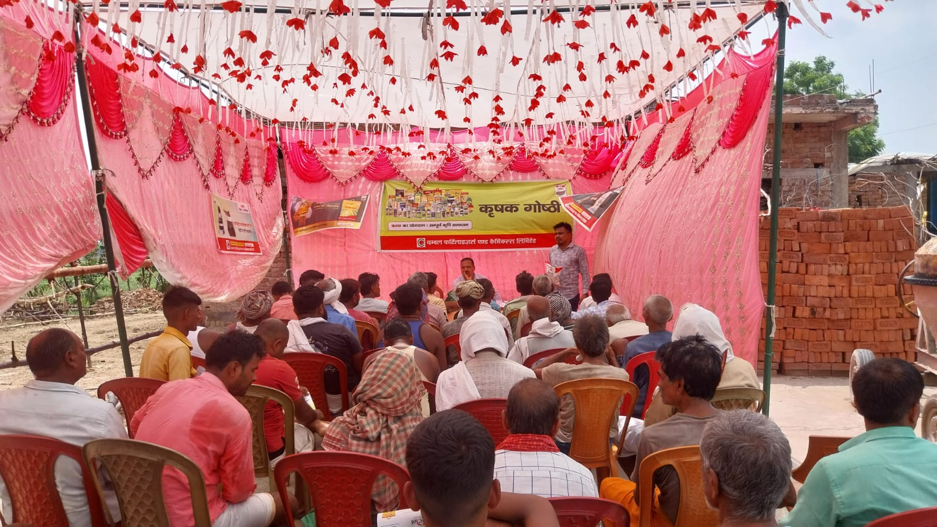
- FarmerMeetingUnderS2H

*Village-Khiri
*District-Buxar
*RMO-Patna

Focus Crop-Paddy Point Discussion -
- Discussion on Cropping pattern in village.
- ExplainthebenefitsofS2HvillageSelectedfarmers.
- Provide information regarding Soil Sample and
importance of Soil sample Report.
- Use of balance fertilizer into crops , FYM uses into soil.
- Benefits of root dipping and foliar spray of Uttam
Pranam in paddy.
- Benefits of applying Uttam superrhiza in the field
before sowing and Mix with FYM.
- Discussion on Paddy Nursery management ,Redwor
and Stem borer.
Focussed products-
SN-Uttam Superrhiza, salfi no Gold, Salton, Etc. CPC - Onvix, Uttam AGROS, Pevota, azole etc.

RetailerParticipation-1. Imran khad bhandar
Name- Md Imran
Mobno-+917739810964

Organisedby: Vivek Kumar (UKS- Buxar)
Meeting Attended by- Ashish Pratap Sir (AMM Sasaram)

